* **Activity 4:**

Using the MINUS Operator

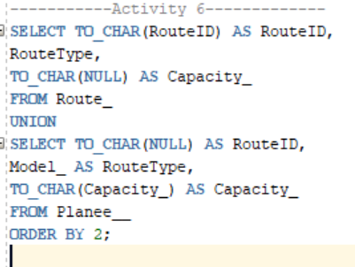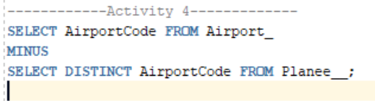

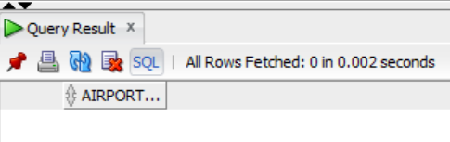OUTPUT: